实验11 TestDirector的安装与基本操作

|  |  |  |  |  |  |  |  |
| --- | --- | --- | --- | --- | --- | --- | --- |
| 组 别 |  | 实验人员 | KAFLE SAMRAT | | | | |
| 实验项目名称 | TestDirector的安装与基本操作 | | | | | | |
| 实 验 类 别 | 验证型□ 设计型□ 综合型□ | | | | | | |
| 实 验 工 具 | Windows、mysql、TestDirector8.0 | | | 实验地点 | J13-132 | 实验日期 | 2020.12 |
| 学生实验小结 | 通过实验得知TestDirector是基于web的测试工具，它能够指导进行测试需求定义、测试计划、测试执行和缺陷跟踪，即整个测试过程的各个阶段。 | | | | | | |
| 教师评语 | 指导教师签名：  年 月 日 | | | | | | |
| 实验成绩 |  | | | | | | |

1实验内容和目标

1.1实验内容

本实验主要学习TestDirector的安装，熟悉使用TestDirector系统地控制整个测试过程，使整个测试过程变得更为简单和有组织

1.2实验目标

（1）掌握安装TestDirector的方法；

（2）熟悉TestDirector各个模块基本操作

2实验方案设计

2.1实验环境

Windows2003、mysql、TestDirector

2.2实验方法设计

安装TestDirector，了解Site Administrator站点管理程序各个模块的功能。熟悉Customize测试项目管理平台，熟悉TestDirector测试过程管理平台

3实验步骤和结果

Task 1: Install TestDirector

(1) Preparation before installation Operating system: Windows Server 2003, database: MySQL install IIS Test Director8.0 installation package

(2) Unzip the TD installation file and run the setup.exe file.

(3) Enter the corresponding license and Maintenance values, respectively: KSQMQSQ-HQSQDQS-Q3QSQ3S-Q2SSQI8，B343P-44B44-43444-6444S.

(4) Select the corresponding database.

(5) Create the database server name, generally use the default value.

(6) Then install the user name and password of the machine where the TD is located. If the machine does not have a password, one must be created, and the user name and password must be the user and password of the administrator of the machine. (The user name is recommended through Browse. It may be wrong to enter it manually.)

(7) After selecting and entering the user name and password, you need to choose the corresponding installation path. There is no need to change the following steps, and you can confirm the installation.

Task 2: Create a project or domain

1. Open TD and click Site Administrator on the left;

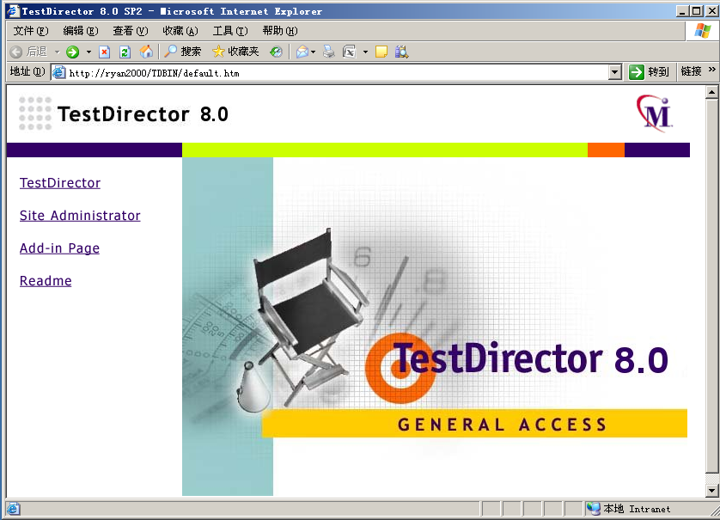

1. Enter the password (the initial password is empty, you can click "Change Password" to change the password, which is only applicable to this interface), and enter the Site Administrator interface;

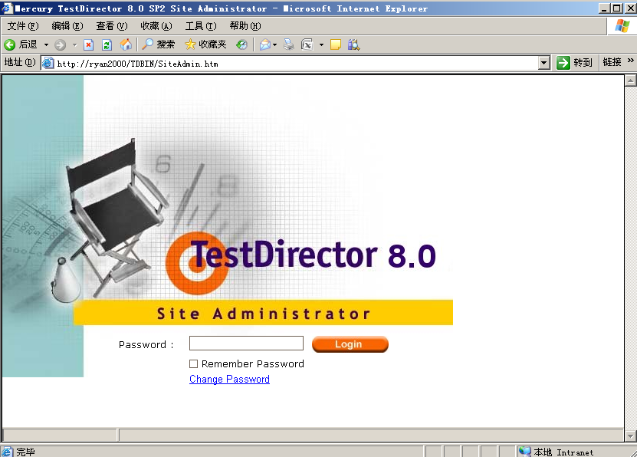

1. Select Default, right-click and click Create Domain in the pop-up menu;

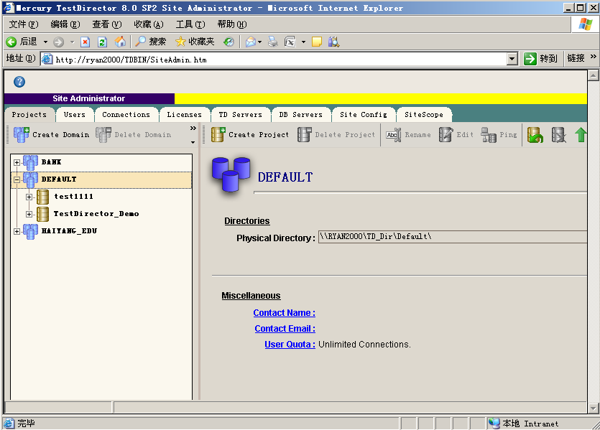

1. Enter the Domain name in the Domain name and select the database (if you have multiple databases installed, you need to select the database Which database is the domain based on)

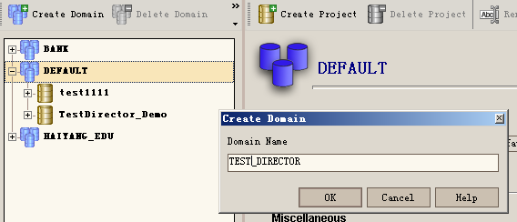

1. Select a domain, right-click, and click Create Project in the pop-up menu

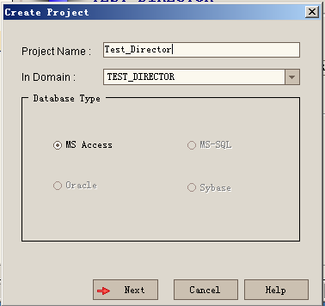

1. Enter the Project name in Project Name and select the database (if you have more than one database installed, you need to choose which database to build the Project on).

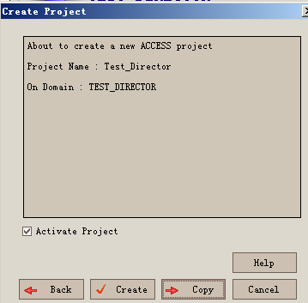

Task 3: Create new user group (role) and user group (role) authorization

1. After logging in TD, click Customize in the upper right corner to enter Project Customize

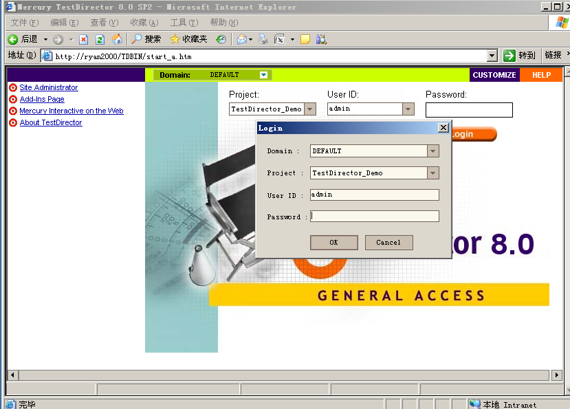

1. Click Set Up Groups in the Project Customize page, and the system will pop Up the Set Up Groups window

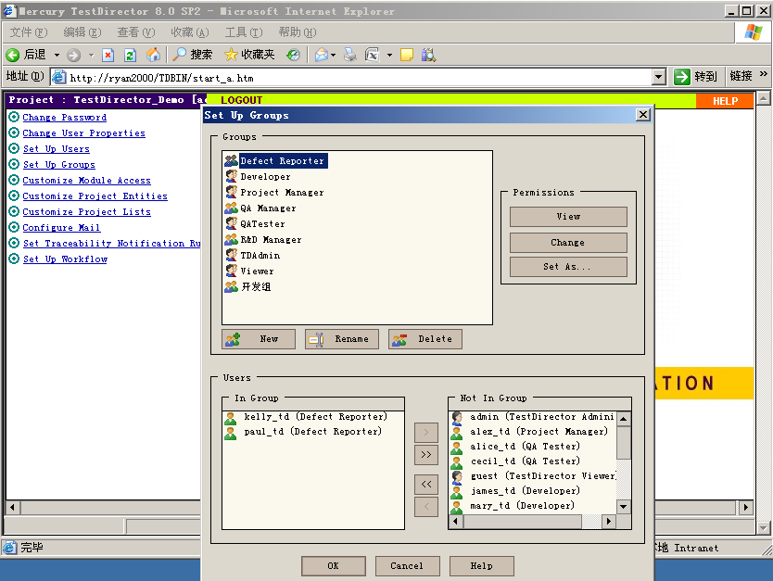

(3) Click New in the Set Up Group window to pop Up the New Group window.

(4) Enter the user Name in Name. And select a user group, and the purpose of selecting a user group here is to create a user group that, initially, has the same permissions as the user group that you selected. Click OK when finished. A confirmation box will pop up and click Yes.

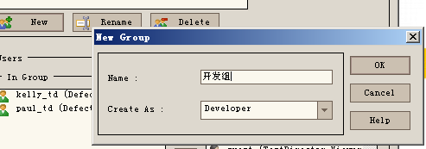

(5) modify the permissions of this user group. Select the group of users that you want to modify permissions, and click Change in the Permission field. The system pops up the Permission Settings page. On the Permission Settings page, modify the user's permissions.

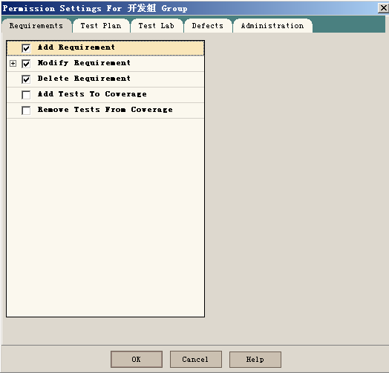

Click Set Up Uses in the Project Customize page, and the system will pop Up the Set Up Uses window;

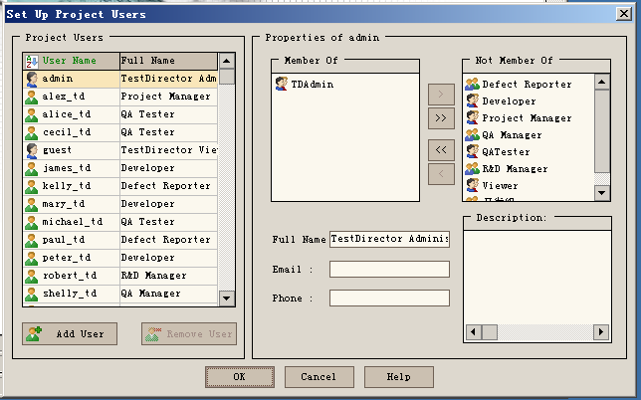

(6) Click Set Up Uses in the Project Customize page, and the system will pop Up the Set Up Uses window;



1. Click Add User in the Set Up Group window, and the Add User to Project window pops Up
2. Click New in the Add User to Project window, and the New User window will pop up.

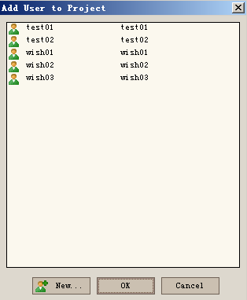

Task 4: Customize the TD usage module

(1) After TD is opened, click Customize in the upper right corner to enter the Project Customize page.

(2) Click Customize Module Access in the upper left corner;

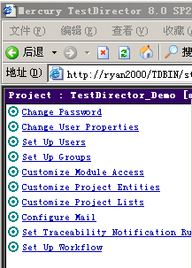

(3) Set the module entry, which can customize the permissions that each role has for TD when logging in.

Checking Defects Modul means that only defect management functions are available for all members of this role once they are logged in to TD;

A tick under TestDirector means that only defect management functionality is available when all members of that role log in to TD.

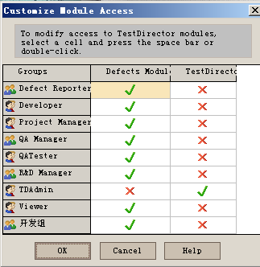

Task 5: Customize defect fields

1. After logging in TD, click Customize in the upper right corner to enter the Project Customize interface;

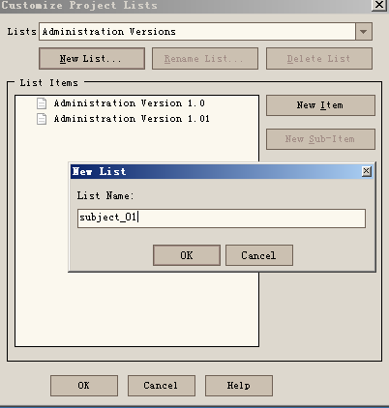



1. Click Customize Project Lists, pop up the following window, create a New list list, click New List, and enter list name subject_01; OK to start adding list items, click New Item

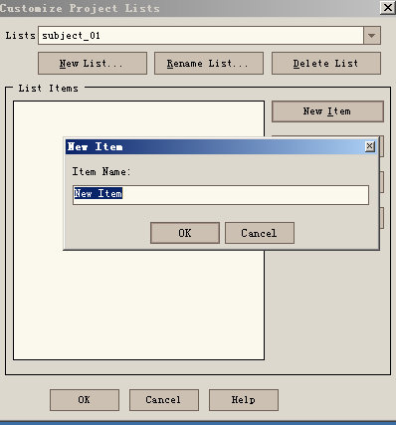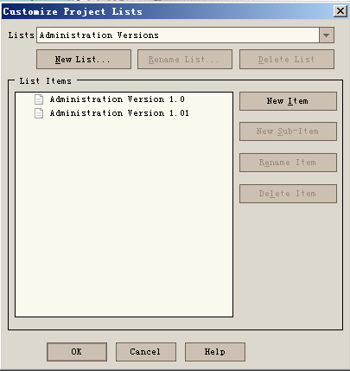

1. Click Customize Project Entities, and the following window pops up. Enter Field Label: Module Name. Since the field of Module Name is a drop-down List box, select Lookup List for all Field Type. Set in the Lookup List corresponding to Customize Project Lists

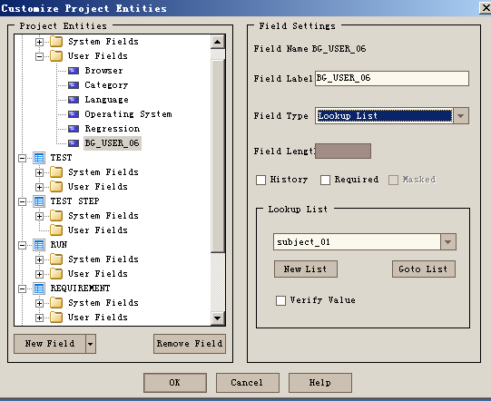

Task 6: Requirements management

1. Enter the main interface of TD, select the name of the project to be logged in, enter the user name and password, and click Login System

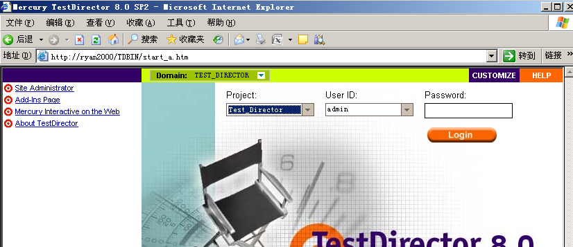

(2) Select the Requirements module

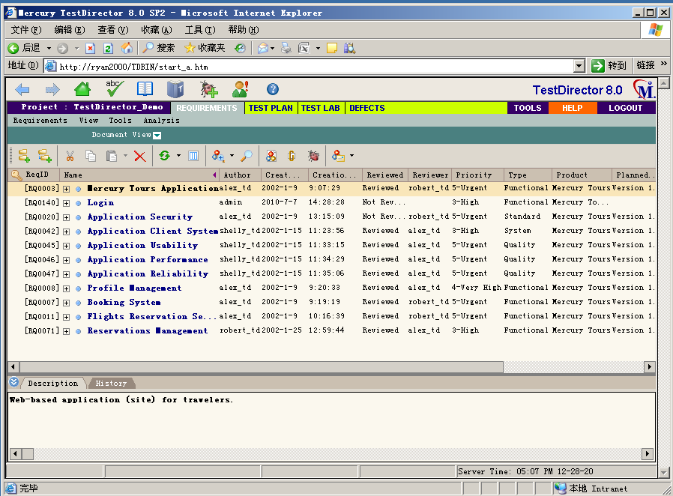

1. To view the defects on the requirements, click the BUG button, and a window will be displayed, which displays the bugs corresponding to the requirements first;

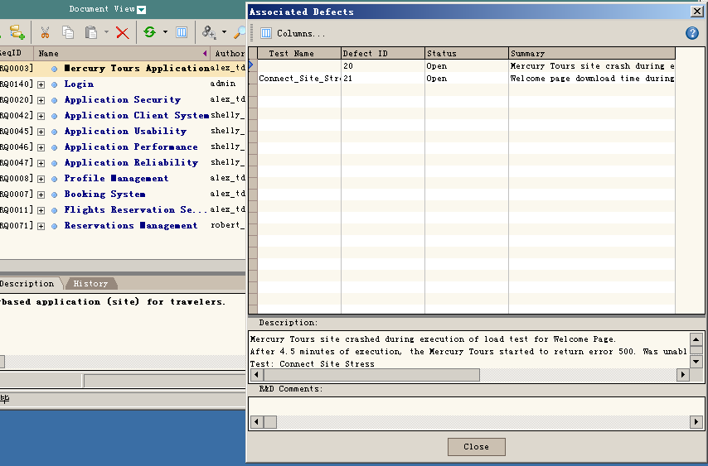

1. Select a requirement, right-click Generate Test, and click OK. This requirement will be established as a Test. There will be a corresponding record in the test tree, and the test will be associated with the requirement.

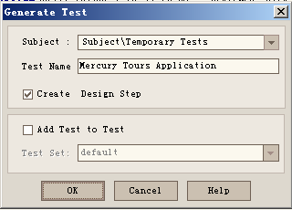

1. Click Analysis and select Graphs to view the demand status in the form of an icon.

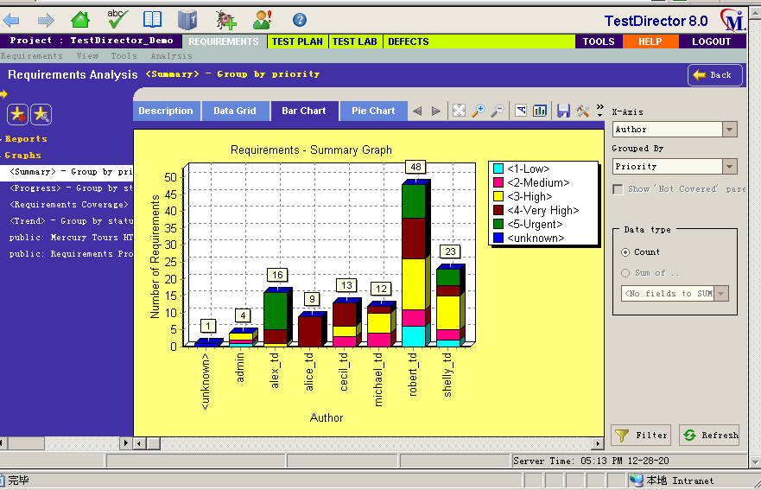

Task 7: Test plan management(任务七：测试计划管理)

1. Select the Test Plan module;

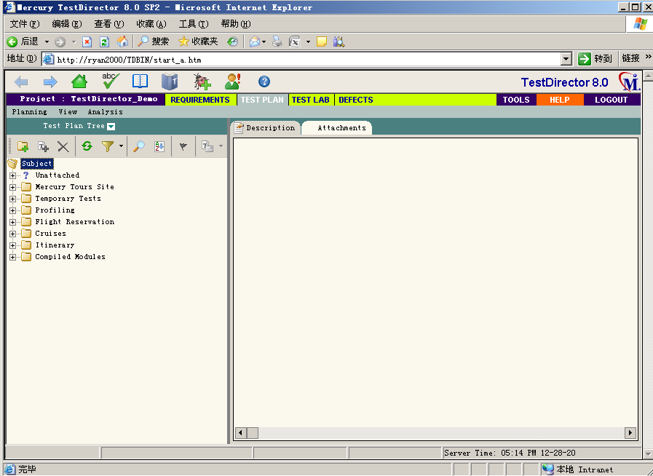

1. Click the New Folder to set up the test plan Folder;

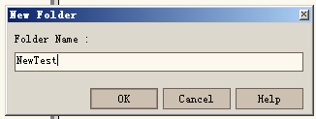

1. Select a folder and click Create New Test to establish a Test plan;

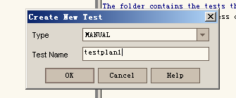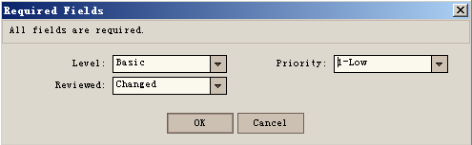

1. Right-click on a test and select Associate Defect to Associate the BUG with the test;

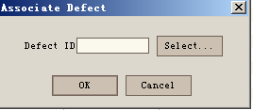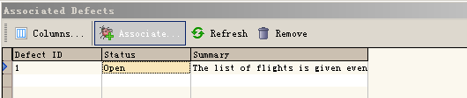

1. Click the TAB of Reqs Coverage -- click the Select Req button, and the demand tree will pop up. Right-click the menu of Add to Coverage on the demand tree, and the demand and test can be successfully associated; Or in the interface of defining requirements, click the Select Tests button, and the test plan tree will be displayed on the right side of the interface. Click the "Add to Coverage" menu to connect successfully.

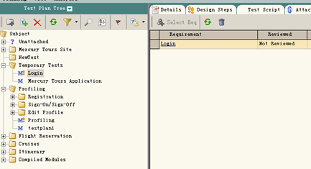

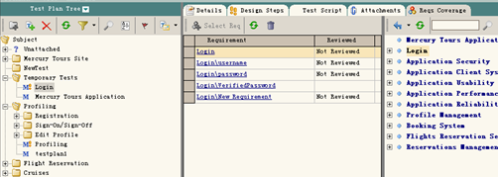

1. Click the Design Steps TAB to add test steps;

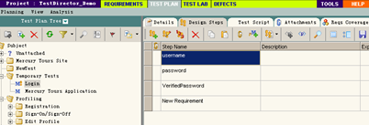

Task 8: Execute the test(**执行测试**)

1. Select Test Lab module;

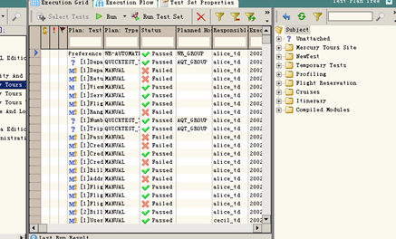

1. Click Select Tests and Select the test from the test plan on the right;

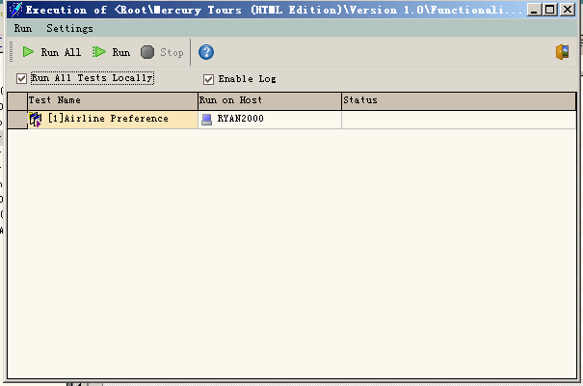

1. select any test, each test can be modified;

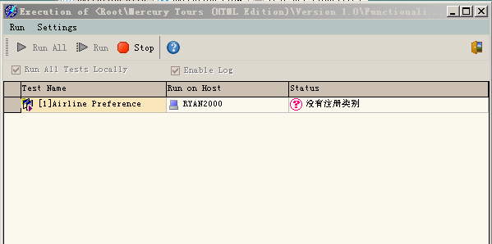

Click Start Test to perform manual tests;

(5) Click Exec Steps, you can add test Steps, delete test Steps, pass test, fail test;

(6) Click the "Run Test Set" button to execute the automatic Test;

(7) Click the Run button to execute the automatic test. Click the Run All button to execute All the automatic tests. The order of execution of the automatic tests will follow the previous automatic test execution plan. If the automatic test execution time is set, it will not execute the automatic test until the specified time.

Click the Stop button to stop the automatic tests that are being performed. After executing the automatic test, the results of the automatic test will be shown. Click the Run -- View Execution Log menu to see the results of the automatic test.

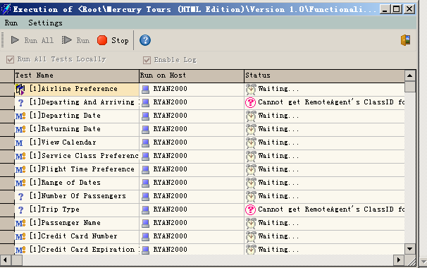

Task 9: Document defects(记录缺陷)

(1) Select the Defects module;

(2) Click Add Defect.

(3) Click the Find Similar Defects button to Find if there is the same Bug;

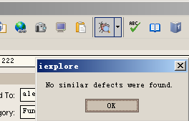

1. A defect in the defect table can be directly selected for modification;

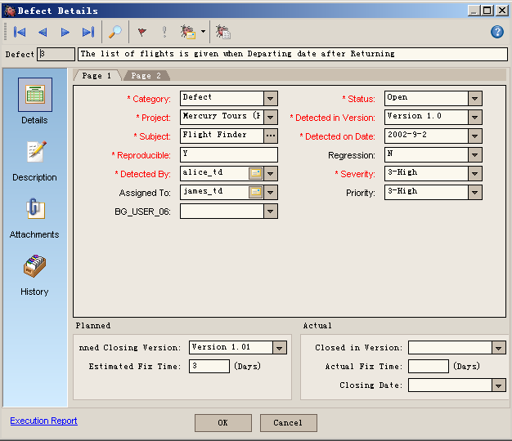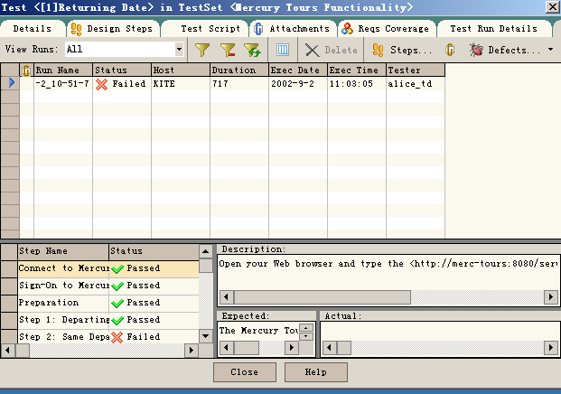

1. Select a defect, right-click and select Associated Test to view the Associated Test;

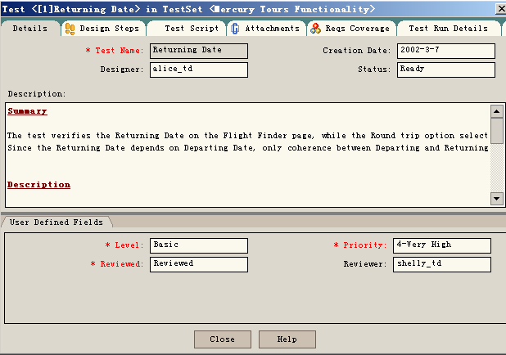

4.实验结果分析

Tests show that TestDirector is a Web-based testing tool, which can guide test requirements definition, test planning, test execution and defect tracking, i.e., all stages of the entire testing process.